**THE DCE-MRI PERFUSION MAPPING GUI**

**QUICK USER’S GUIDE**

**PAWEŁ TOKARCZUK**

**14. I. 2020.**

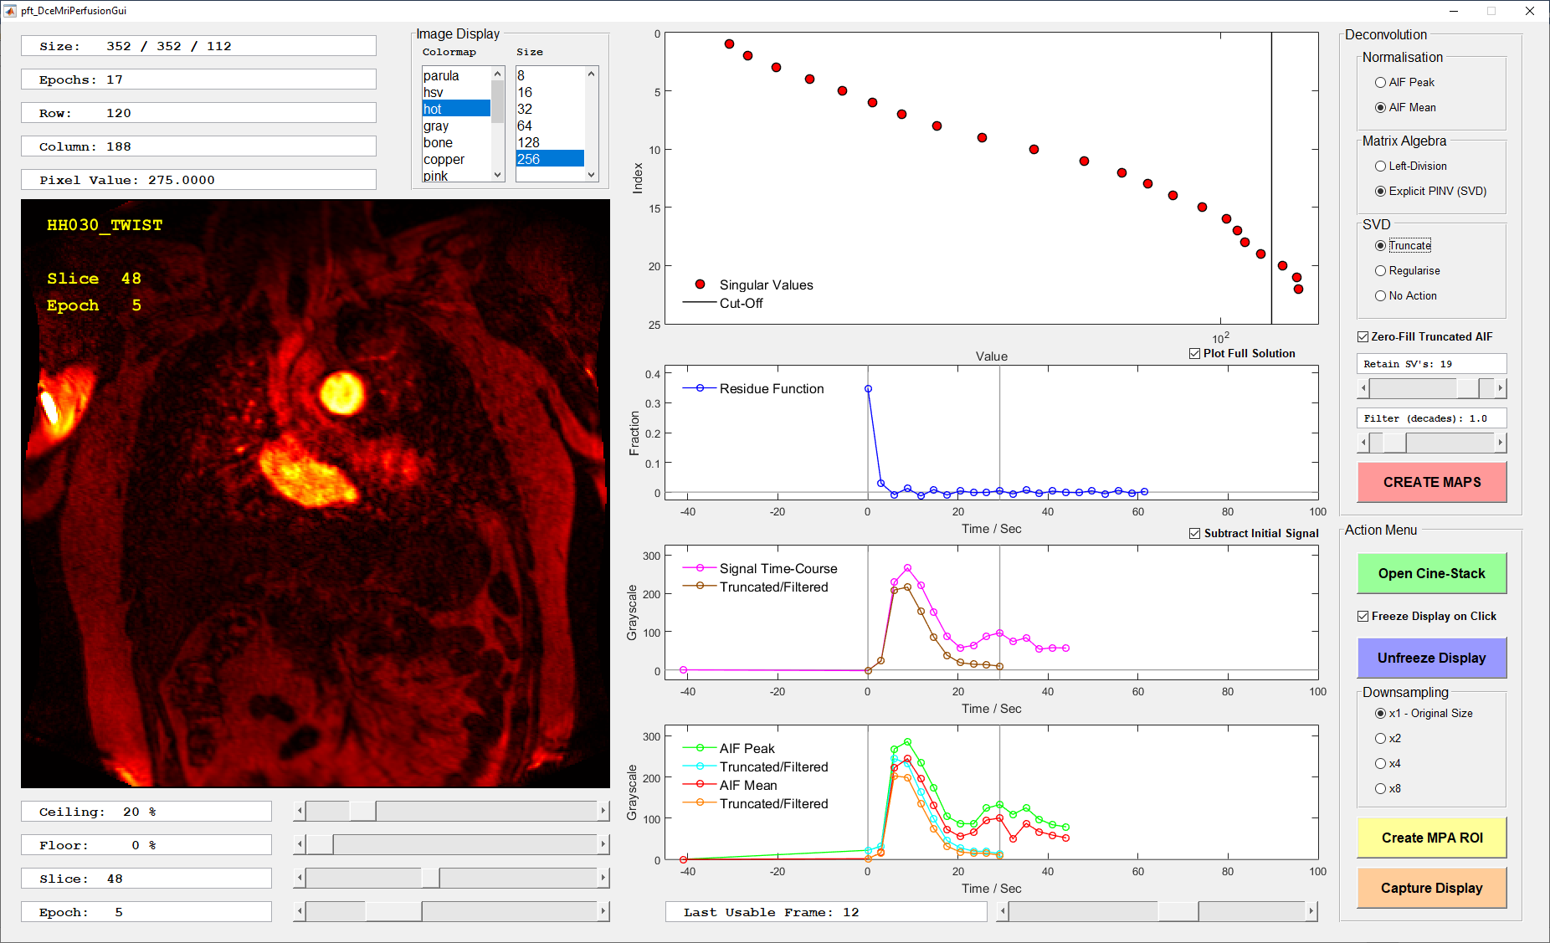

**Figure 1. The GUI in action, with some processing decisions already made.**

**Introduction**

This is intended as a quick, imperative guide to using the software; a detailed technical explanation is given in the companion document.

**Preparation**

If you are intending to use the GUI outside the Steiner Suite, then initialise the paths to the source data and results using the script:

***pft_InitialiseFolders***

**Getting started**

Open a ciné-stack using the big **green** button.

Select a “pickled” MAT file from those on offer.

Use the sliders at the bottom left of the dialog to window the image display and to navigate between Epochs and Slices.

You can also change the colormap of the image display using the menus at the upper left, and the resolution using the downsampling options in the lower right corner.

**Processing decisions**

Although the dialog has a good many controls, most of these were introduced during an exploratory phase of test-driven development, and in practice, you should be able to leave most of them at their default values. However, there are some unavoidable decisions that you need to make before you can create the quantitative perfusion maps.

1. Last Usable Frame.

The images in each perfusion ciné-stack are acquired during long breath-holds, and it will often happen that the subject struggles to hold his breath right to the end. You therefore need to identify the Last Usable Frame before the breath-hold fails.

Begin by navigating to a slice in which some major organs are visible: lungs, liver, spleen and kidneys. Advance the Epoch slider until you see the first unusable frame. Roll back to safety by one epoch.

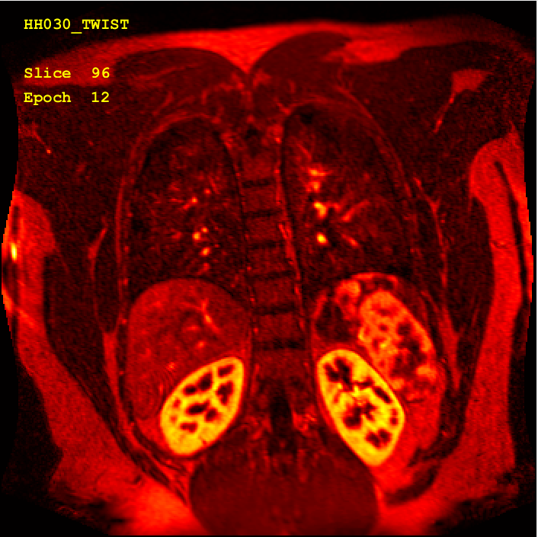 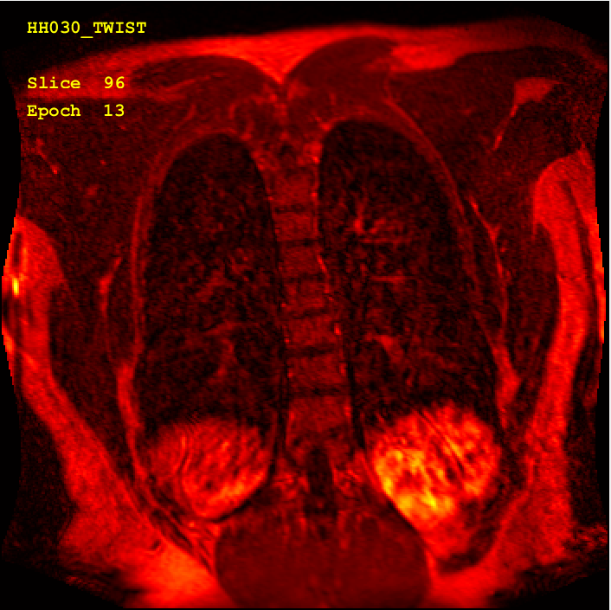

**Figure 2.a. Last usable frame at Epoch 12. Figure 2.b. First discarded frame.**

1. MPA region of interest.

Navigate to the slice in which the section through the MPA is most nearly circular.

Click the large **yellow** button to create the ROI.

A circle will appear in the image display. Move and re-size it with the mouse, then double-click to select the visible region.

Four versions of the Arterial Input Function will now appear in the lower axes on the dialog: Mean and Peak, also with and without apodisation.

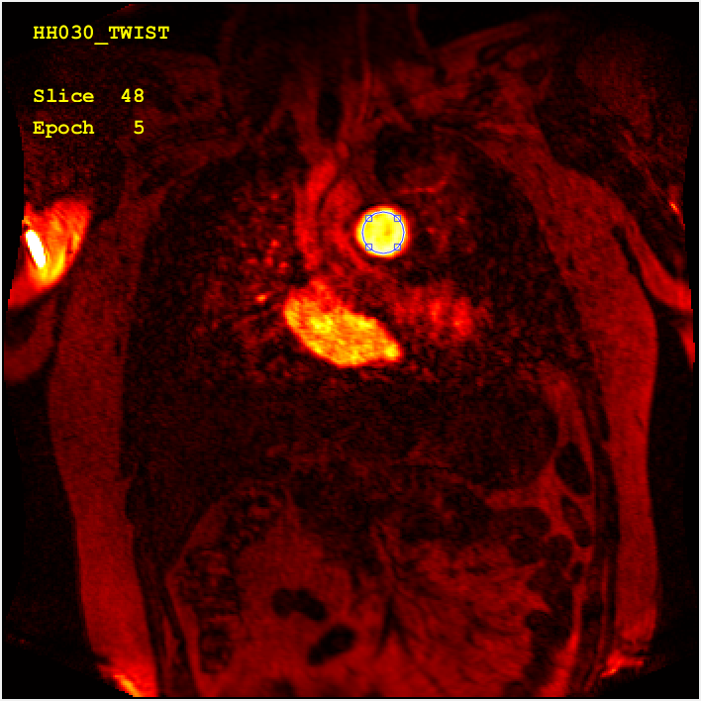

**Figure 3.a. Creating the MPA ROI.**

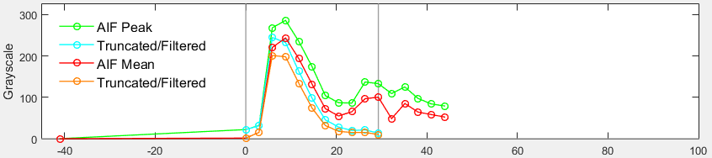

**Figure 3.b. The Arterial Input Function.**

**Note the vertical grey markers showing the first and final epochs**

**used in the later calculation.**

1. Deconvolution controls.

The mapping depends on a deconvolution of the AIF from the pixel-wise signal time-course effected by the administration of the contrast agent.

There are two ways to see the effect of changes in the processing parameters on the deconvolution:

1. Move the mouse inside the image display axes. You will see a time-course being displayed and updated, and a residue function being calculated in real time, using fixed parameters:

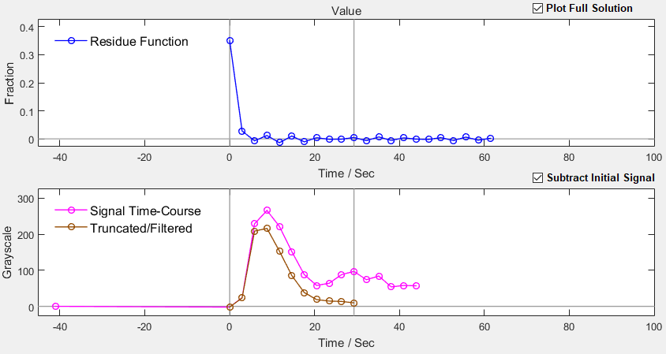

**Figure 4. The time-course at a given voxel, with the deconvolved residue function.**

1. Freeze the image display with a click of the left mouse button within the image. If you are unsatisfied with the chosen voxel, unfreeze the display with the purple button and choose another. You can now make changes to the Deconvolution controls in the upper right section of the dialog.

The obvious way in which to adjust the deconvolution controls is to create a time-course from within the MPA ROI; this is will be very similar to the AIF, so the deconvolved residue function should look a lot like a delta-function at time zero.

Pay attention to the following options:

**Deconvolution**

**Normalisation**

**Matrix Algebra**

**SVD**

**Zero-fill Truncated AIF**

You shouldn’t need to change any of these, although you’re free to experiment.

The really critical controls are:

**Retain SV’s**

**Filter (decades)**

The following screenshots show a visually good set of parameters, along with some poor ones.

Note that too little filtering creates a sharp (truncation) step in the data, with evident noise in the residue function. On the other hand, too much filtering results in a loss of information, and constrains the deconvolution excessively: 1.0 decades seems to be a good working value.

The singular values fall into distinct groups (these are plotted at the top of the dialog, with Index running from top to bottom and Value from left to right, in order of decreasing size). Values to the left of the vertical separator are retained (if relevant) and those to the right are discarded. Retaining too many values may create an “over-fitted” noisy residue function, whereas keeping too few yields an oscillatory and clearly wrong result.

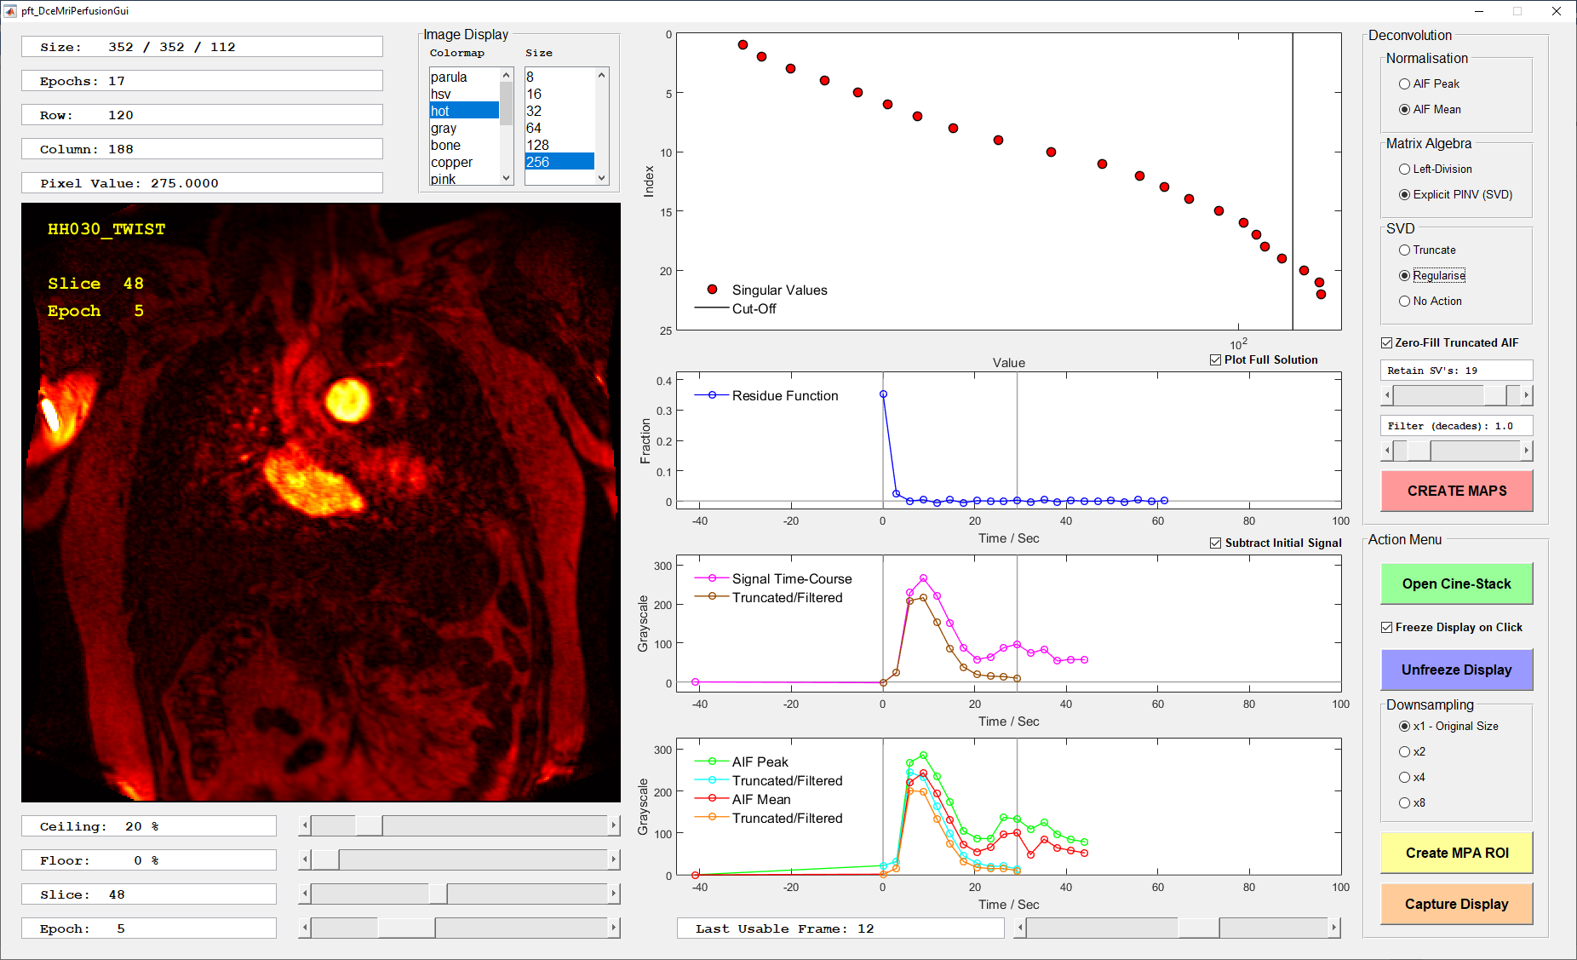

**Figure 5.a. A good deconvolution.**

**The choice of SVD management (Truncate, Regularise, No Action) has only a small effect on the result.**

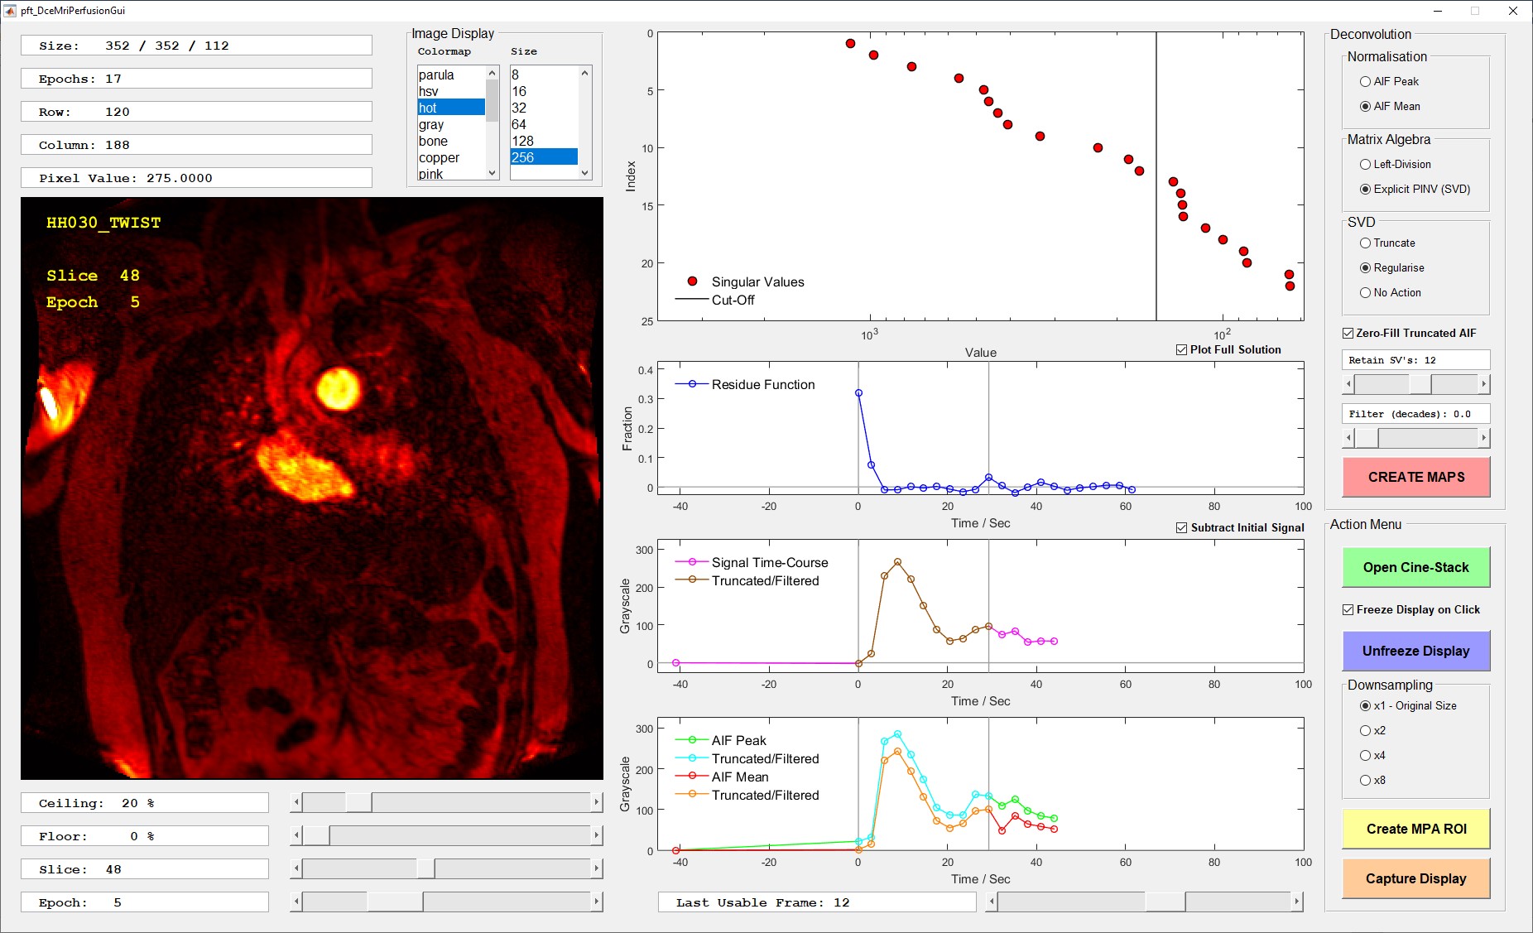

**Figure 5.b. The previous good result is made worse when the filtering is removed, so that the data are sharply truncated,**

**and too few singular values are retained.**

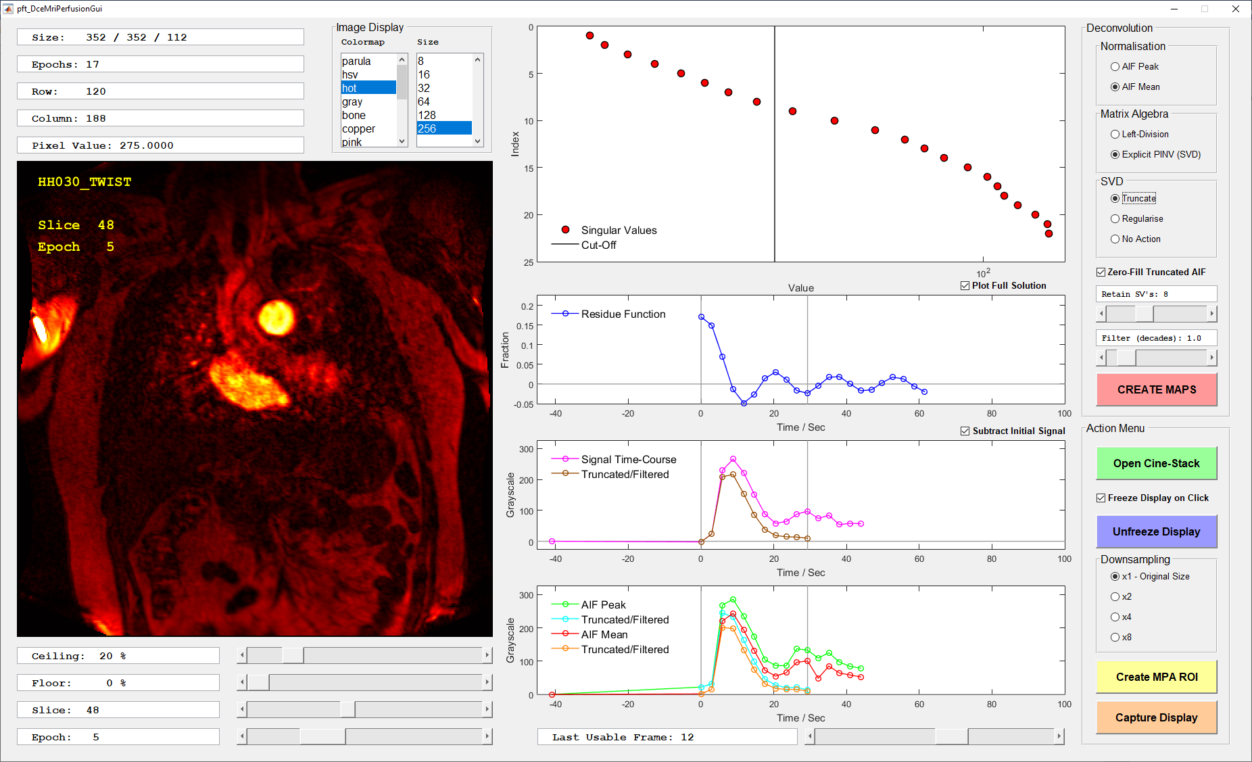

**Figure 5.c. Too few singular values have been retained, and the oscillatory residue function is clearly wrong.**

**Note that the amount of filtering applied in this situation makes very little difference.**

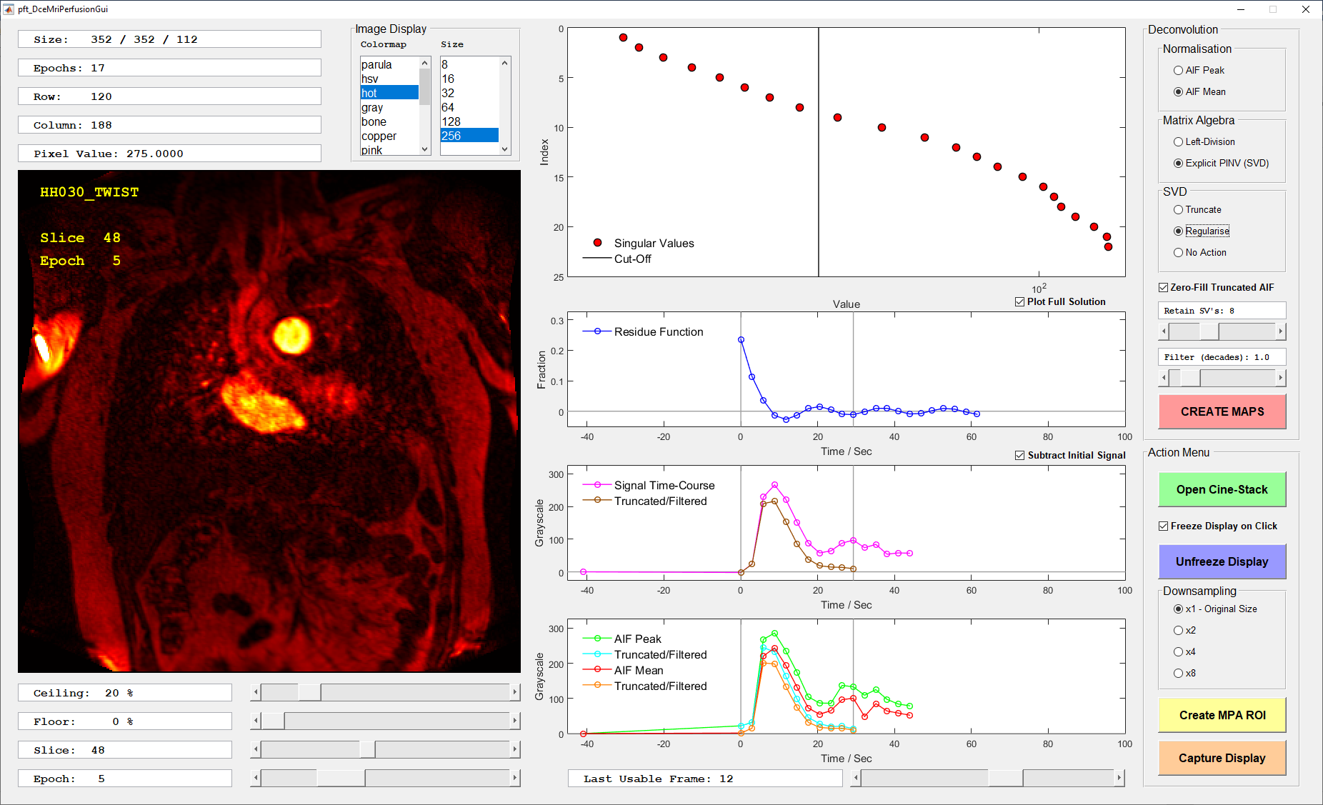

**Figure 5.d. Using Regularisation rather than Truncation of the singular values has slightly improved the previous poor result.**

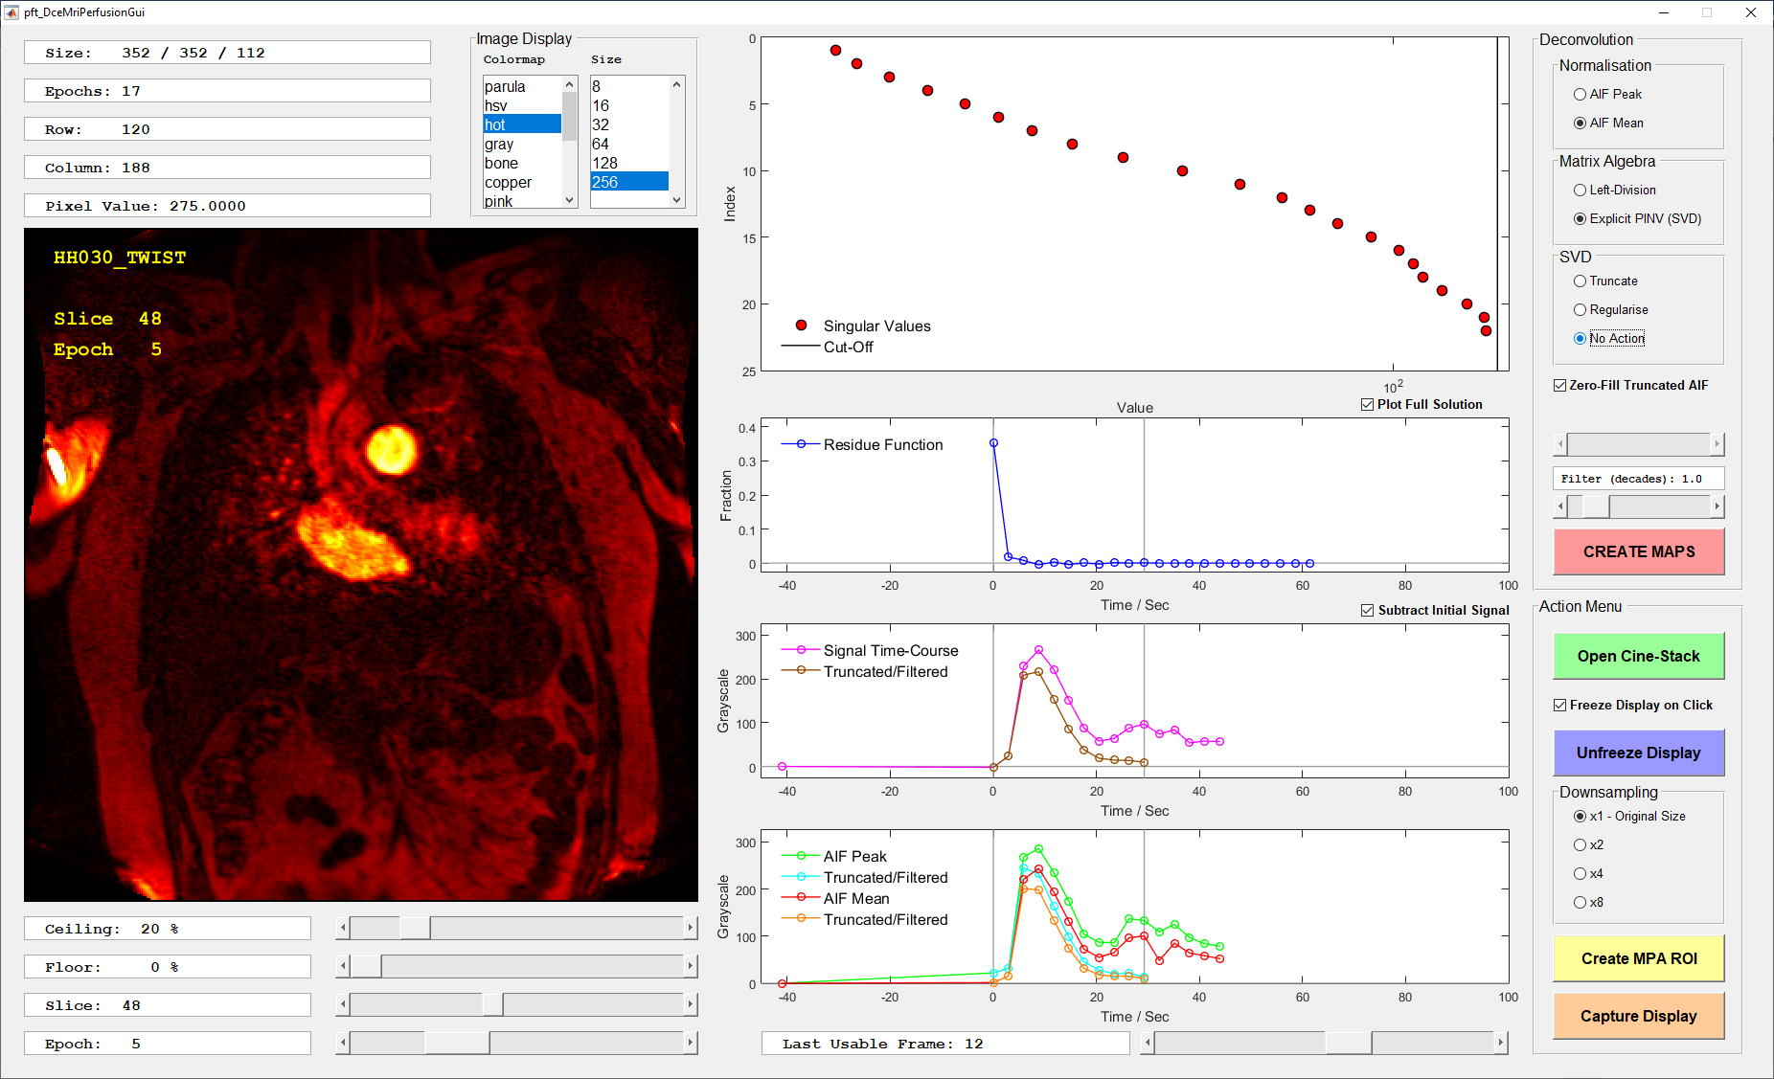

**Figure 5.e. Using all the singular values (“No Action”) yields a good result in this case.**

**Quantitative mapping**

Once you have set your deconvolution parameters, press the pink button to create the maps. It’s best to accept any filenames offered by the dialog at this stage; results for a given study are automatically numbered, so that nothing can be overwritten.

You will be prompted for a time-course threshold, expressed as a percentage of the maximum in the AIF. The legal values are in the range 1 – 50 %; the default is 10 %, though even 5 % gives a good result without creating too much background noise.

***If you would like to reduce the minimum threshold to zero, please let me know – it’s a one-line fix.***

The outputs at this stage are:

* An Excel file with a summary of the processing parameters, grouped into several tabs.
* A black-and-white image of the MPA region of interest.
* A MAT-format “pickle” which can be read by other MATLAB applications further downstream.
* A folder of DICOM files, grouped into sub-folders.

The last of these has the following maps:

* Pulmonary blood volume (PBV): both filtered and unfiltered.
* Pulmonary blood flow (PBF): again, filtered and unfiltered.
* Time to peak (TTP).
* Mean transit time (MTT).

Note that the last two “time-like” maps are set on a baseline to distinguish unprocessed voxels from those with physical low or zero values. Obviously, the TTP map will be “chunked” into just a few bins.

The dialog will keep you informed of progress. A full analysis at the native image resolution may take 5 minutes or so, although every factor of 2 in the downsampling results in a factor of 8 speed-up.

Note that, although there is nothing to prevent you acquiring the AIF at one resolution, and creating the maps at another, you should avoid this, since you won’t strictly be comparing like with like in that case.

**Documenting your choices**

Notice the orange “Capture Display” button; this will save images of all the axes (though it may not catch all the legends). Obviously, another straightforward route is **Alt-PrtScr, Paint, Ctrl-V and File | Save As.**